Biosecurity Code of Practice – Template
Introduction
Angling activities can unintentionally spread invasive species and diseases between rivers, lakes, canals and fisheries through wet equipment, boats, keepnets, landing nets, waders, bait buckets and other angling gear. Many invasive species and pathogens are difficult to detect and can survive for long periods in damp conditions.
Both Ireland and Northern Ireland have legislation prohibiting the intentional and accidental introduction or release of both invasive and non-native species. All members, visiting anglers and event participants share responsibility for maintaining high biosecurity standards.
Biosecurity best practice is critical and can significantly reduce the risk of introducing and spread of invasive species and diseases (insert name of club/group) have a responsibility to ensure the club/groups activities follow best practice. Our members are an essential partner in helping to protect the waters we love to spend time in.
Code of Practice Aims
The aims of this Code of Practice are:
- To prevent the introduction and spread of invasive species and fish diseases between catchments visited by members of (insert name of club/group).
- To protect (insert name of club/group) from invasive species and diseases introduced
by visiting anglers, clubs or event participants.
- To promote awareness and consistent implementation of biosecurity best practice throughout all angling activities, competitions and events.
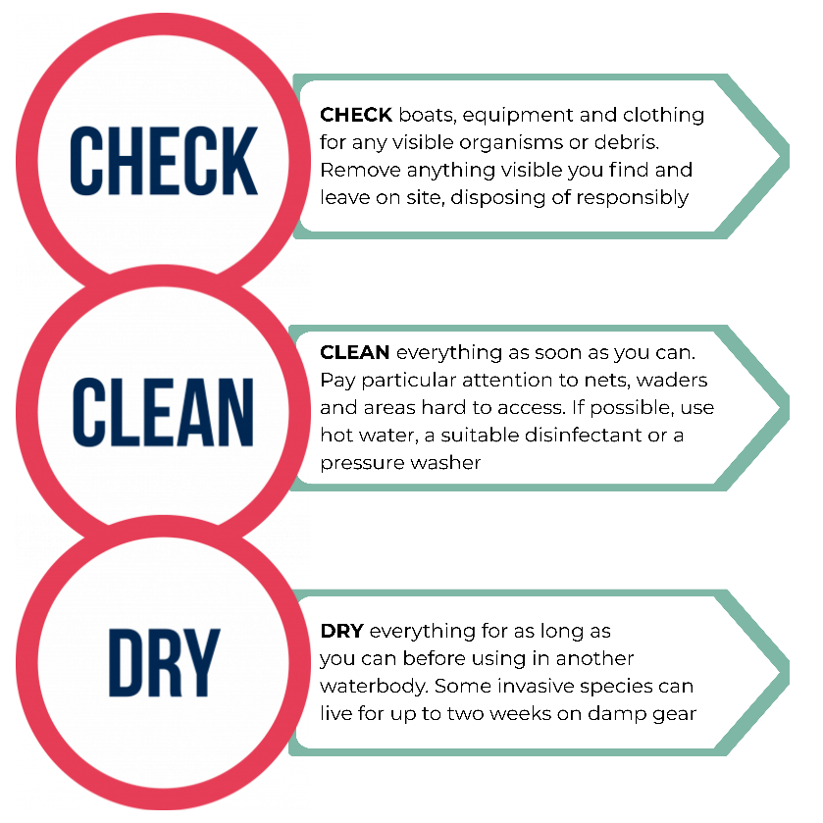
Code of Practice Measures
The “insert name of club/group” has adopted the simple three step method, Check Clean Dry as our biosecurity approach to protect our waterbodies from invasive species.
This fundamental principle is to check and clean your clothing, equipment and anything else that could carry visible or invisible living organisms from one location to another. Remembering to drain water from every part of your boat and trailer before leaving the site. The hull of a boat and tailer can dry when being towed.
It is particularly vital to do this when moving between waterbodies even if there are days or weeks between visits. For example, if you fish in the Lough Erne one weekend and the River Boyne the next, you could be unintentionally transporting invasive species.
Dip Tank Procedures
Where drying equipment fully is not practical, (insert name of club/group) will utilise disinfectant dip tanks and spray stations to reduce the risk of spreading invasive species and fish diseases.
- Equipment should first be checked and cleaned of all visible debris before entering the dip tank.
- Equipment should be immersed in the disinfectant for the minimum contact time recommended by the manufacturer.
- Disinfectant concentrations must be mixed according to manufacturer instructions.
- Dip tank solutions to be replaced regularly to maintain effectiveness.
- Used disinfectant to be disposed of safely and away from watercourses.
- Dip tanks to be clearly signed and easily accessible to all participants.

Biosecurity Equipment Available
Items of equipment that require attention include both club and privately owned; (list equipment related to your club/groups activity. For example, personal floatation devices, wetsuits)
(Add to this section on the club/groups available wash down equipment. For example “in the club house, disinfectant spray is available)

For further information on the Check Clean Dry protocol please visit:
Check Clean Dry –invasivespeciesni.co.uk (Northern Ireland)
Check Clean Dry - Invasives.ie (Ireland)

Training and Awareness
All members, volunteers and event participants must familiarise themselves with this Biosecurity Code of Practice.
Members and event participants may be required to sign a declaration confirming they:
- Have read and understood the Biosecurity Code of Practice
- Agree to follow the Check Clean Dry protocol

Biosecurity Measures for Visiting Anglers and Clubs
All visiting clubs or individuals will be required to follow the Check, Clean, Dry approach as outlined in this Code of Practice document. Additional controls to be implemented include:
- Event participants must complete a biosecurity declaration during registration (template provided ).
- Pre-event communications will advise participants of biosecurity responsibilities and equipment requirements (template provided).
- All visiting equipment will be inspected for visible organisms/materials on arrival at the event.
- Wet or contaminated equipment may require cleaning/disinfection before use and participants may be refused entry if biosecurity standards are not met.
- Participants must clean or disinfect equipment before leaving the site.
- Biosecurity reminders will be announced during event briefings and weigh-ins.
For downloadable resources and awareness raising materials please visit:
Check Clean Dry Resources – Invasive Species Northern Ireland (Northern Ireland)
Check Clean Dry - Resources - Invasives.ie (Ireland)

Biosecurity Champion
To achieve effective biosecurity, “insert club/group name” has an appointed/nominated a Biosecurity Champion. The Biosecurity Champions Programme brings together local communities, clubs and groups who care about our waterways across Northern Ireland and Ireland.
This voluntary programme is designed to be simple, practical and flexible, providing ready-made tools and support to help you protect your local waters from invasive species by sharing key messages and supporting small, practical actions.
If you are interested in becoming a Biosecurity Champion or would like more information please email ”insert email address”.
- Our Biosecurity Champions:
Name and email address of current champions.

Members and Competitors Biosecurity Declaration

I hereby agree to abide by the “insert club/group name” Biosecurity Code of Practice.

I understand that the following biosecurity standards apply at all times:
- I will Check Clean and Dry all clothing and equipment prior to arrival to the event/club site
- I will ensure equipment can be inspected for visible organisms/materials on arrival to the event/club site
- I understand if I arrive with damp or dirty kit I may be turned away from participating in the event
- Before leaving the water’s edge, I will remove any visible materials/organisms and leave on site
- I will use the available wash stations/dip tanks to clean clothing and equipment prior to leaving the event/club site
- I will report any invasive species I see to the event organiser or club

Signature:

Date:

