Biosecurity Code of Practice – Template
Introduction
Biosecurity is a set of practical measures used to minimise the risk of introduction and spread of invasive species and diseases. An invasive species is a plant, animal or pathogen that has been introduced into a new environment. The impacts of an invasive species are significant, they can damage the environment, the economy and our health. Invasive species are easily spread when we move to a new waterbody, they can hitchhike on clothing and equipment as they can be small and hard to spot.
Both Ireland and Northern Ireland have legislation prohibiting the intentional and accidental introduction or release of both invasive and non-native species. Our club and members should take every effort to ensure compliance.
Biosecurity best practice is critical and can significantly reduce the risk of introducing and spread of invasive species and diseases (insert name of club/group) have a responsibility to ensure the club/groups activities follow best practice. Our members are an essential partner in helping to protect the waters we love to spend time in.
Code of Practice Aims
To prevent the introduction or spread of invasive species and diseases:
- To/from any other catchment visited by member of “(insert name of club/group)”
- To the “(insert name of the catchment/water body of the club/group)” by visitor watersport users
Code of Practice Measures
The “insert name of club/group” has adopted the simple three step method, Check Clean Dry as our biosecurity approach to protect our waterbodies from invasive species.
This fundamental principle is to check and clean your clothing, equipment and anything else that could carry visible or invisible living organisms from one location to another.
It is particularly vital to do this when moving between waterbodies even if there are days or weeks between visits. For example, if you kayak in the Lough Erne one weekend, and the River Boyne the next, you could be unintentionally transporting invasive species.

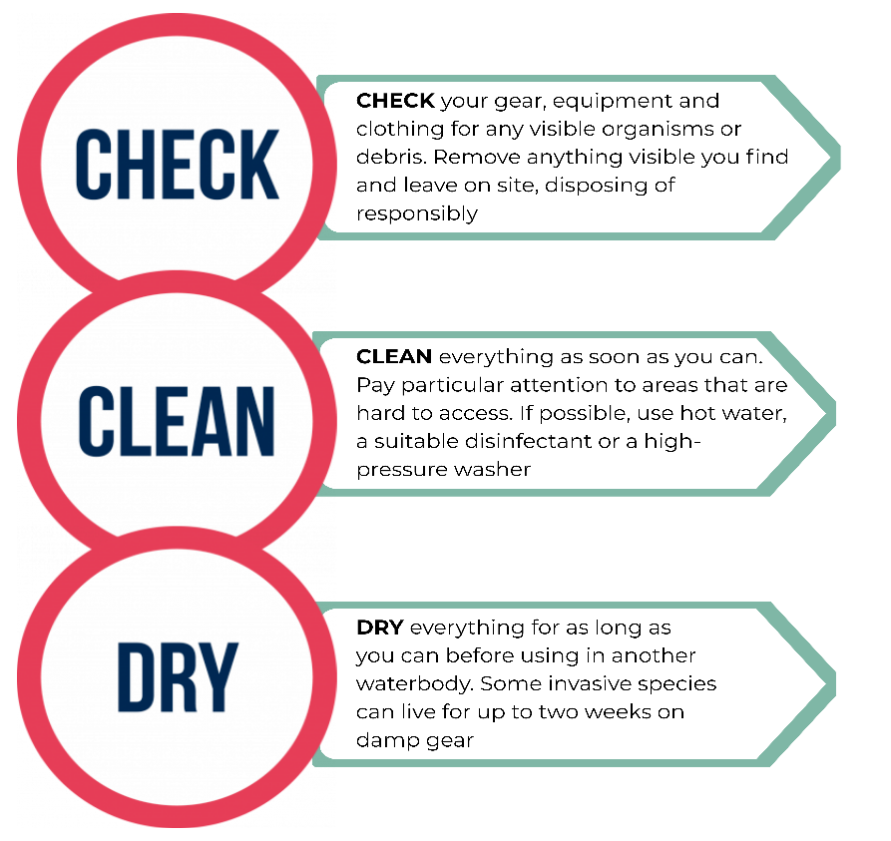
Note:
- If you cannot clean at the site, you can pack away your clothing and gear in a laundry bag
(or something similar) and clean with hot tap water when you return home, before entering a new waterbody
- If complete drying is not possible then disinfect everything, making sure you read the manufacture guidance on dilution and disposal.
- Anyone that is visiting Ireland bringing their own boats and equipment please take extra care to ensure all gear arrives clean and dry

When should I use disinfectant?
- When complete drying is not possible equipment can be disinfected
- Read manufactures instructions to ensure proper dilution and safe handling
- Try to immerse your clothing and equipment, for at least 15 minutes
- If spraying onto gear, undertake away from water’s edge and on hard standing ground
- Please follow manufacture guidance on when to replace the disinfectant, as it loses effectiveness over time
- Be cautious with sensitive gear as disinfectant may damage fragile equipment

Items of equipment that require attention include both club and privately owned; (list equipment related to your club/groups activity. For example, personal floatation devices, wetsuits)
(additional point to include if your club/group often uses boats: Remembering to drain water from every part of your boat and trailer before leaving the site. The hull of a boat and tailer can dry when being towed.)
Biosecurity Equipment Available
(Add to this section on the club/groups available wash down equipment. For example “in the club house, disinfectant spray is available)

For further information on the Check Clean Dry protocol please visit:
Check Clean Dry – Invasive Species Northern Ireland
(Northern Ireland)
Check Clean Dry - Invasives.ie (Ireland)

Training
All new members/participants must familiarise themselves with the Biosecurity Code of Practice and adhere to the procedures which is available on our website at: “insert website address”
Members/participants will be required to complete a declaration confirming they have read and understood the Biosecurity Code of Practice and have agreed to adhere to the measures
Biosecurity Measures for Visiting Clubs/Groups
All visiting clubs or individuals will be required to follow the Check, Clean, Dry approach as outlined in this Code of Practice document. Additional controls to be implemented include:
- Visitors are required to submit a declaration (template provided in appendix) as part of event registration process, that all clothing equipment have been checked, cleaned and dried prior to arrival at the event site.
- We will communicate to visitors their responsibility for maintaining biosecurity through the protocol Check, Clean, Dry during the registration process. This gives visitors time to ensure their equipment are drained of water and cleaned thoroughly.
- All visiting equipment will be inspected for visible organisms/materials on arrival at the event location. Visitors who arrive with damp or dirty kit will be required to visit the cleaning stations prior to the event and may be turned away from participating in the event.
- Visitors to check and clean their clothing and equipment prior to leaving the event site using the wash station available.
- At the launch and closing of the event, participants will be reminded of their responsibilities in relation to biosecurity measures required.
For downloadable resources and awareness raising materials please visit:
Check Clean Dry Resources – Invasive Species Northern Ireland (Northern Ireland)
Check Clean Dry - Resources - Invasives.ie (Ireland)

Biosecurity Measures for Events
“Insert club/group name” events involve the transfer of equipment between waterways for the purposes of training, leisure activities or competition. Incorporating biosecurity measures in the planning stage of all events is crucial as such events have the potential to introduce and spread invasive species and diseases.
- Include biosecurity hazard and risks mitigation measures into the club Safety Framework & Risk Assessment for club organised events.
- Raise awareness of Check Clean Dry to participants through pre-event information and the registration process.
- During the registration process, the Check Clean Dry protocol will be communicated, giving participants time to ensure their equipment are drained of water and cleaned thoroughly.
- Equipment to be inspected for visible organisms/materials. Removal of anything visible and leave on site.
- Wash stations to be available for participants to clean clothing and equipment prior to leaving the event site (any large equipment should be washed using a hosepipe/power washer. The washings must be away from the watercourse, contained and disposed of on gravel, hard standing or grass).
- Report any invasive species sightings as every additional record submitted produces a clearer picture of the status of that species across the island of Ireland is generated.

Report a Sighting – Invasive Species Northern Ireland (Northern Ireland)
Report sightings - Invasives.ie (Ireland)

Biosecurity Champion
To achieve effective biosecurity, “insert club/group name” has an appointed/nominated a Biosecurity Champion. The Biosecurity Champions Programme brings together local communities, clubs and groups who care about our waterways across Northern Ireland and Ireland.
This voluntary programme is designed to be simple, practical and flexible, providing ready-made tools and support to help you protect your local waters from invasive species by sharing key messages and supporting small, practical actions.
If you are interested in becoming a Biosecurity Champion or would like more information please email ”insert email address”.
- Our Biosecurity Champions:
Name and email address of current champions.

Members and Competitors Biosecurity Declaration

I hereby agree to abide by the “insert club/group name” Biosecurity Code of Practice.

I understand that the following biosecurity standards apply at all times:
- I will Check Clean and Dry all clothing and equipment prior to arrival to the event/club site
- I will ensure equipment can be inspected for visible organisms/materials on arrival to the event/club site
- I understand if I arrive with damp or dirty kit I may be turned away from participating in the event
- Before leaving the water’s edge, I will remove any visible materials/organisms and leave on site
- I will use the available wash stations to clean clothing and equipment prior to leaving the event/club site
- I will report any invasive species I see to the event organiser or club

Signature:

Date:

